

College Admissions

***Business Analytic Foundation with R Tools- Question***

Abstract

The education department in the US wants to analyze the factors that influence the admission of a student into colleges, to make the entire admissions process easy.

**Presented by: Ankita Agarwal**

**Problem Statement:**

Every year thousands of applications are being submitted by international students for admission in colleges of the USA. It becomes an iterative task for the Education Department to know the total number of applications received and then compare that data with the total number of applications successfully accepted and visas processed. Hence to make the entire process easy, the education department in the US analyze the factors that influence the admission of a student into colleges. The objective of this exercise is to analyze the same.

**Domain**: Education

**Detailed description of the given dataset:**

|  |  |
| --- | --- |
| **Attribute** | **Description** |
| GRE | Graduate Record Exam Scores |
| GPA | Grade Point Average |
| Rank | It refers to the prestige of the undergraduate institution. The variable rank takes on the values 1 through 4. Institutions with a rank of 1 have the highest prestige, while those with a rank of 4 have the lowest. |
| Admit | It is a response variable; admit/don’t admit is a binary variable where 1 indicates that student is admitted and 0 indicates that student is not admitted. |
| SES | SES refers to socioeconomic status: 1 - low, 2 - medium, 3 - high. |
| Gender_male | Gender_male (0, 1) = 0 -> Female, 1 -> Male |
| Race | Race – 1, 2, and 3 represent Hispanic, Asian, and African-American |

**To Analyze:**

Analyze the historical data and determine the key drivers for admission.

Predictive:

* Find the missing values. (if any, perform missing value treatment)
* Find outliers (if any, then perform outlier treatment)
* Find the structure of the data set and if required, transform the numeric data type to factor and vice-versa.
* Find whether the data is normally distributed or not. Use the plot to determine the same.
* Normalize the data if not normally distributed.
* Use variable reduction techniques to identify significant variables.
* Run logistic model to determine the factors that influence the admission process of a student (Drop insignificant variables)
* Calculate the accuracy of the model and run validation techniques.
* Try other modelling techniques like decision tree and SVM and select a champion model
* Determine the accuracy rates for each kind of model
* Select the most accurate model
* Identify other Machine learning or statistical techniques

Descriptive:

* Categorize the average of grade point into High, Medium, and Low (with admission probability percentages) and plot it on a point chart.
* Cross grid for admission variables with GRE Categorization is shown below:

|  |  |
| --- | --- |
| **GRE** | **Categorized** |
| 0-440 | Low |
| 440-580 | Medium |
| 580+ | High |

**Analysis and Interpretations:**

**Predictive**

1. **Find the missing values. (if any, perform missing value treatment)**

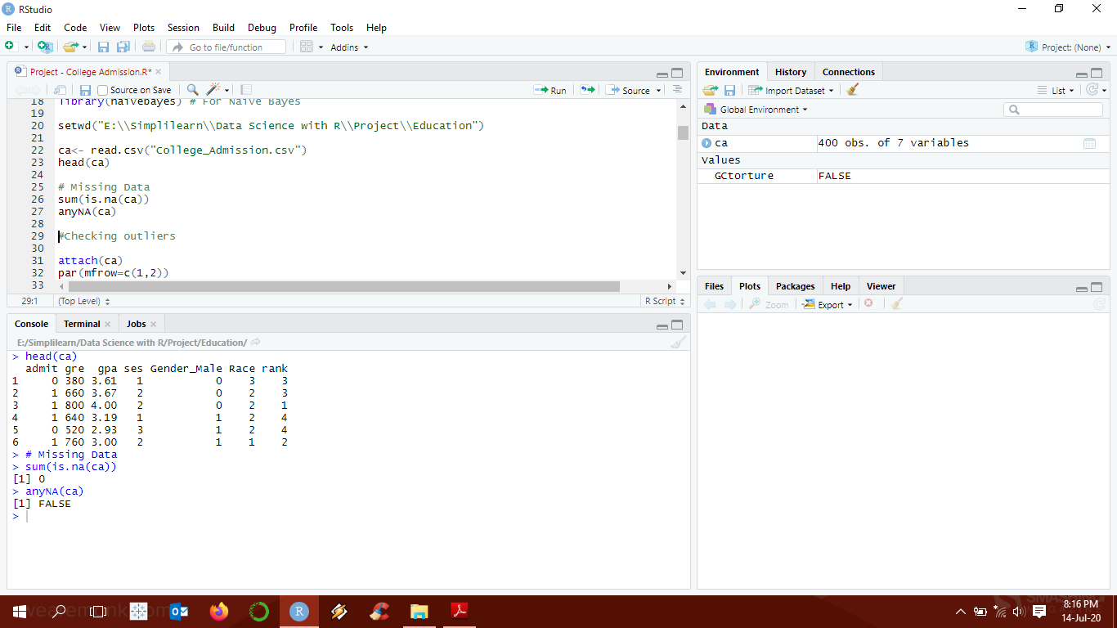

There are no missing values in the given dataset.

1. **Find outliers (if any, then perform outlier treatment).**

Checked outliers using box plots.

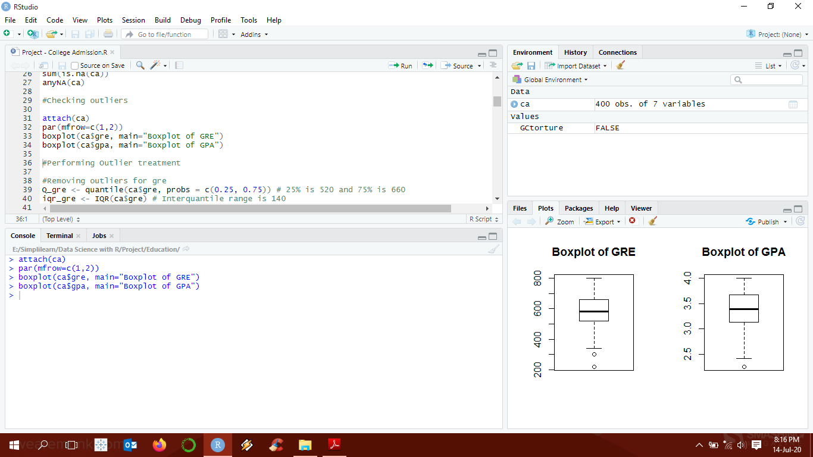

There are outliers in both GRE and GPA. To remove the outliers, we use the equation: (Q1-1.5*IQR) to (Q2+1.5*IQR)

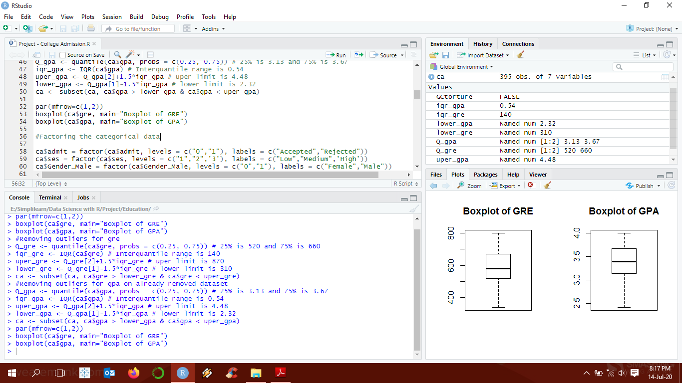

1. **Find the structure of the data set and if required, transform the numeric data type to factor and vice-versa.**

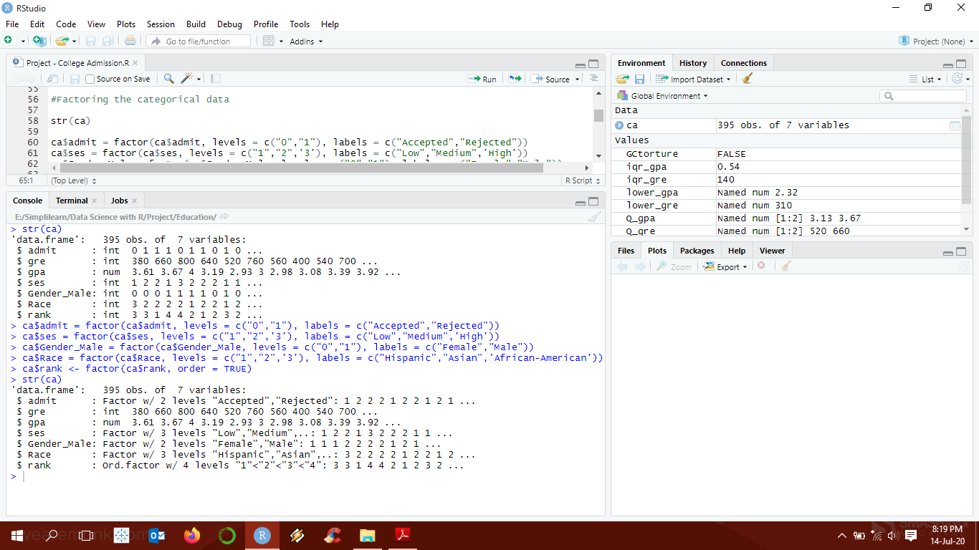

1. **Find whether the data is normally distributed or not. Use the plot to determine the same.**

We use density plots and histograms to check for normality of data.

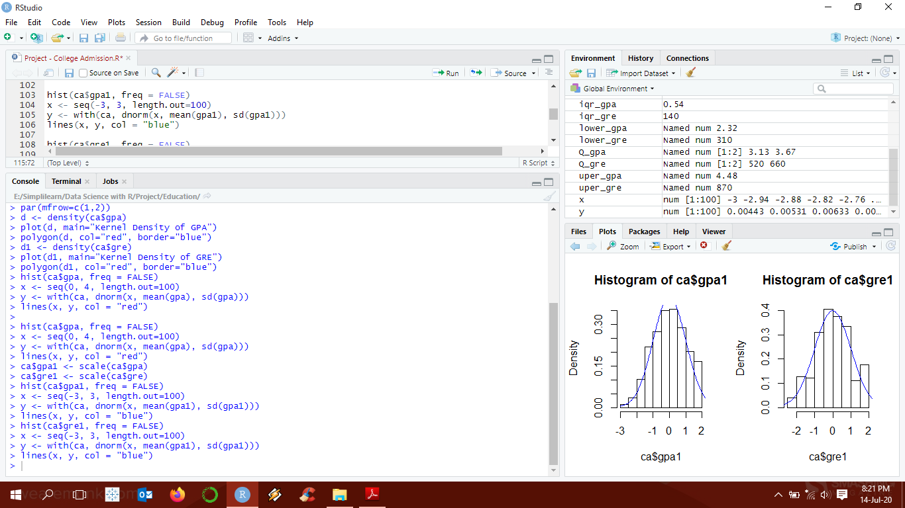

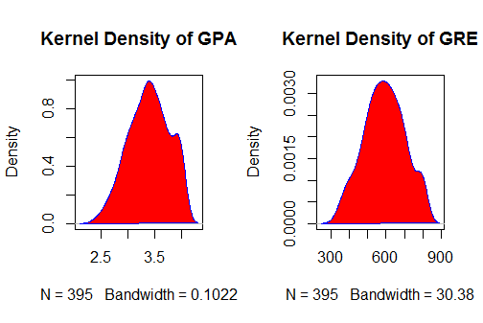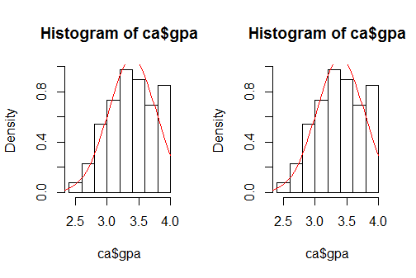

**Interpretation:**

GRE data is not normally distributed: mean (591.2) > median (580.0), so right skewness, GPA also not normally distributed: median (3.4) > mean (3.398), so left skewness.

1. **Normalize the data if not normally distributed.**

Normalized using Scale function

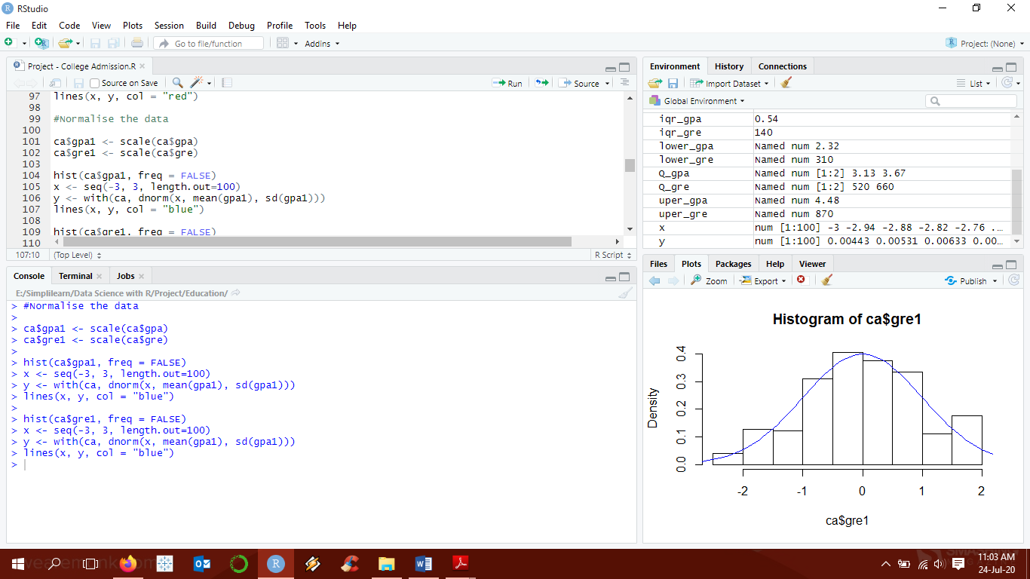

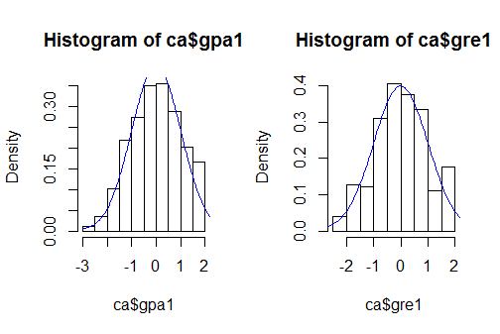

1. **Use variable reduction techniques to identify significant variables.**

Using logistic regression to check significant variables. Also, checking the same using Anova.

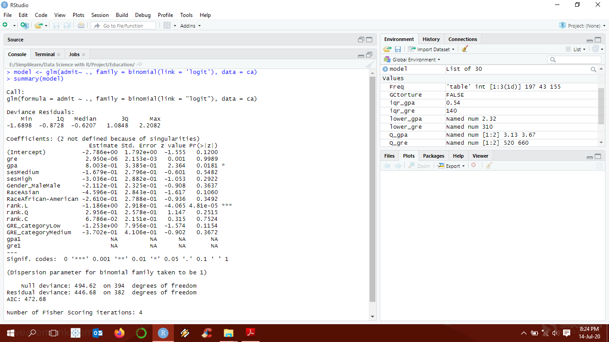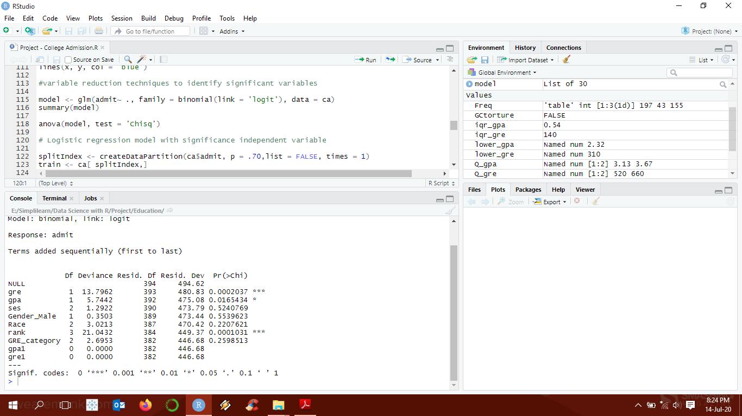

**Interpretation:**

As can been seen clearly, using both logistic regression and Anova, that GRE, GPA and Rank are the only significant variables in the dataset.

1. **Run logistic model to determine the factors that influence the admission process of a student (Drop insignificant variables)**

As we already know that GRE, GPA and Rank are the only significant variables in the dataset. We would be using only these for our analysis. We will spilt the data set into train and test to predict the outcomes and check for accuracy

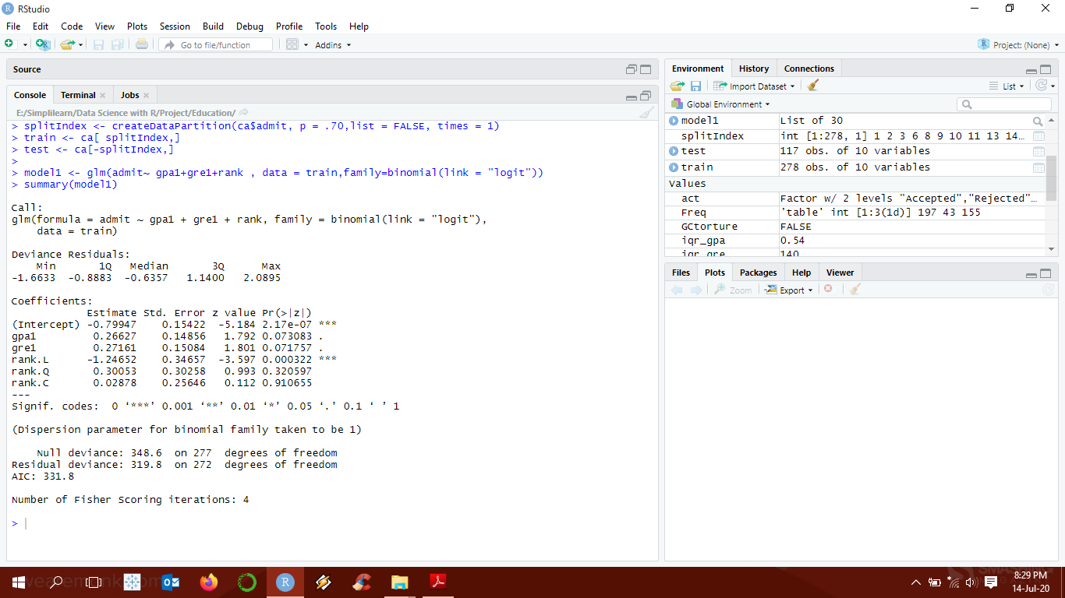

1. **Calculate the accuracy of the model and run validation techniques.**

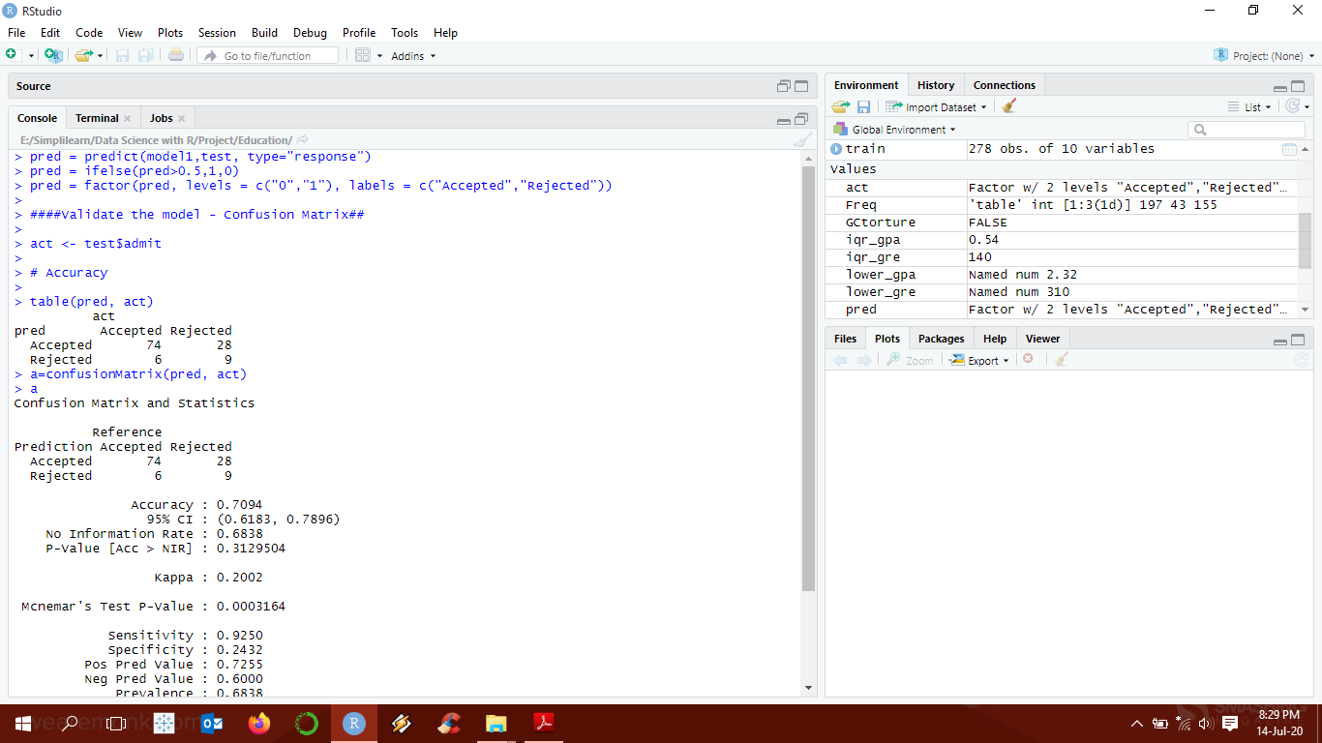

**Interpretation:**

As noted, the accuracy of the model is 70.94%

1. **Try other modelling techniques like decision tree and SVM and select a champion model. Identify other Machine learning or statistical techniques.**

**Decision Tree: -**

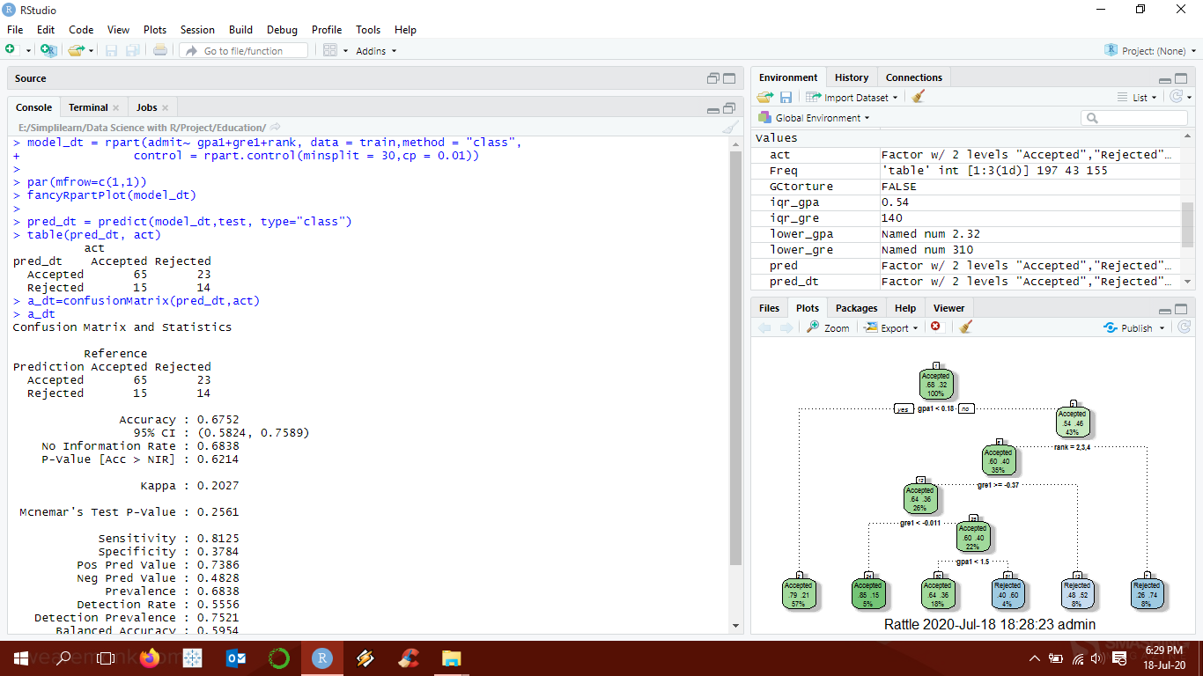

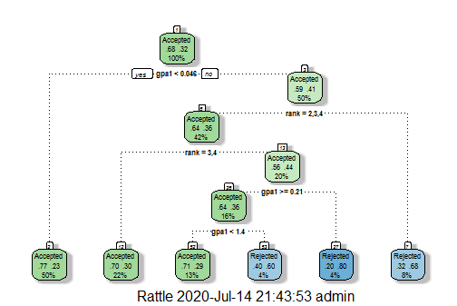

**Interpretation:**

As noted, the accuracy of the model is 67.52%

**SVM: -**

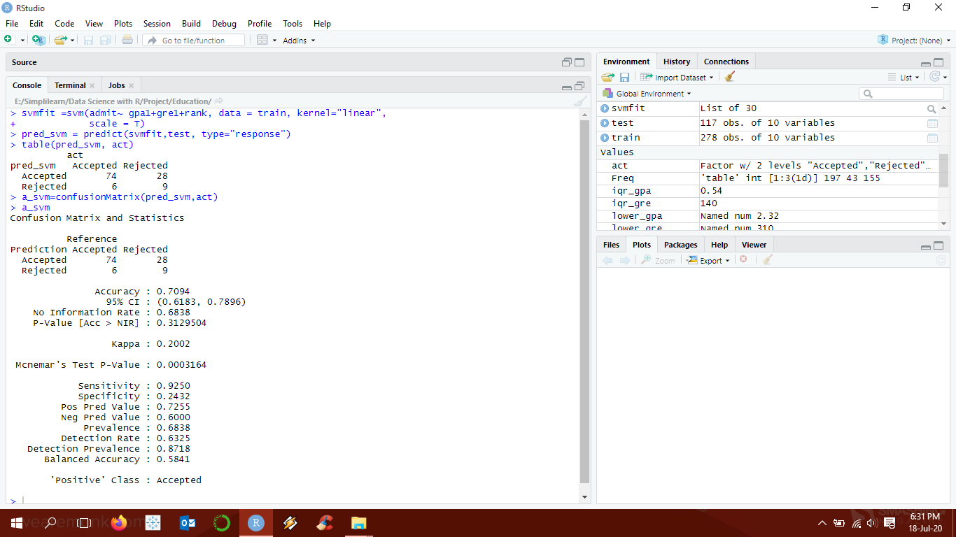

**Interpretation:**

As noted, the accuracy of the model is 70.94%

**Random Forest: -**

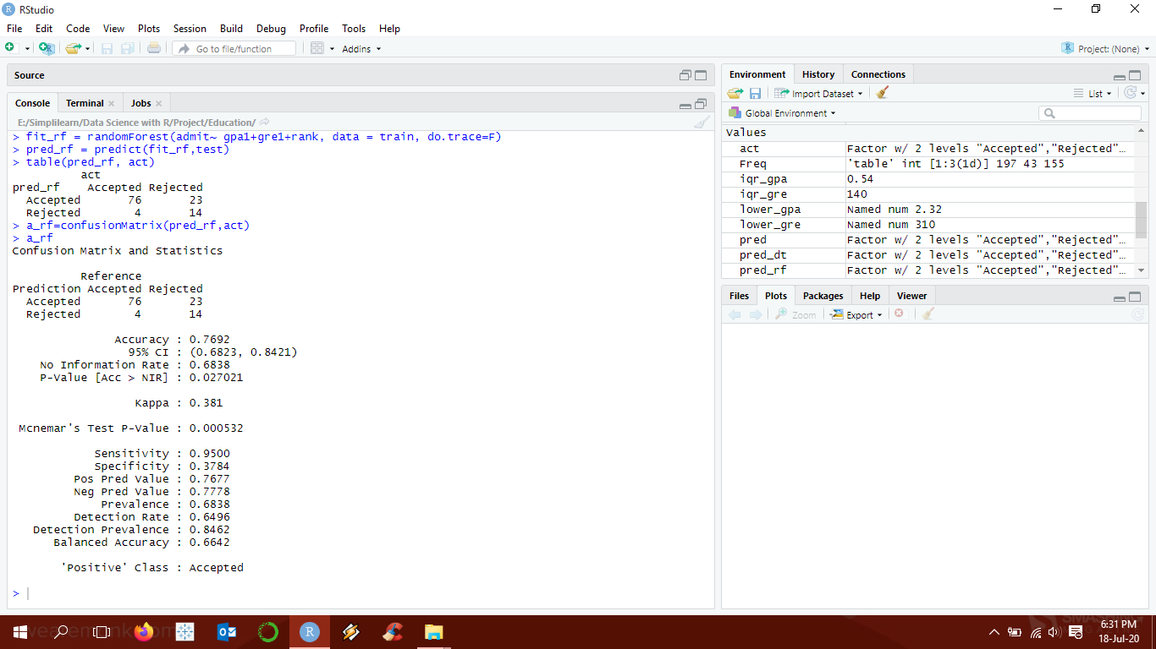

**Interpretation:**

As noted, the accuracy of the model is 76.92%

**Naïve Bayes: -**

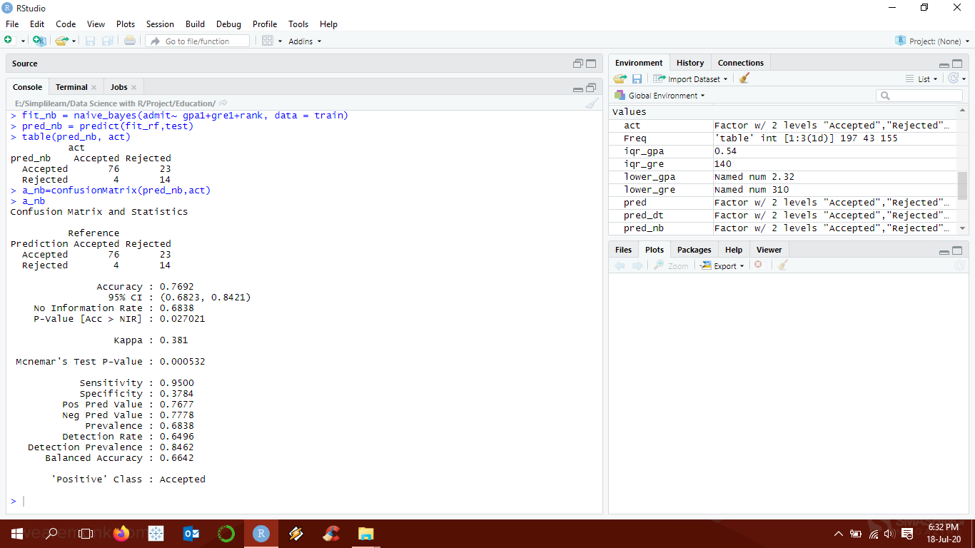

**Interpretation:**

As noted, the accuracy of the model is 76.92%

1. **Determine the accuracy rates for each kind of model. Select the most accurate model.**

|  |  |
| --- | --- |
| **Model** | **Accuracy** |
| Logistic Regression | 70.94% |
| Decision Tree | 67.52% |
| SVM | 70.94% |
| Random Forest | 76.92% |
| Naïve Bayes | 76.92% |

**Interpretation:**

Accordingly, we can say that Random Forest or Naïve Bayes is the most accurate Model.

**Descriptive**

1. **Categorize the average of grade point into High, Medium, and Low (with admission probability percentages) and plot it on a point chart. Cross grid for admission variables with GRE Categorization is given above.**

GPA data are categorized using K-means clustering using K=3. The clusters and admission probability of them are summarized below.

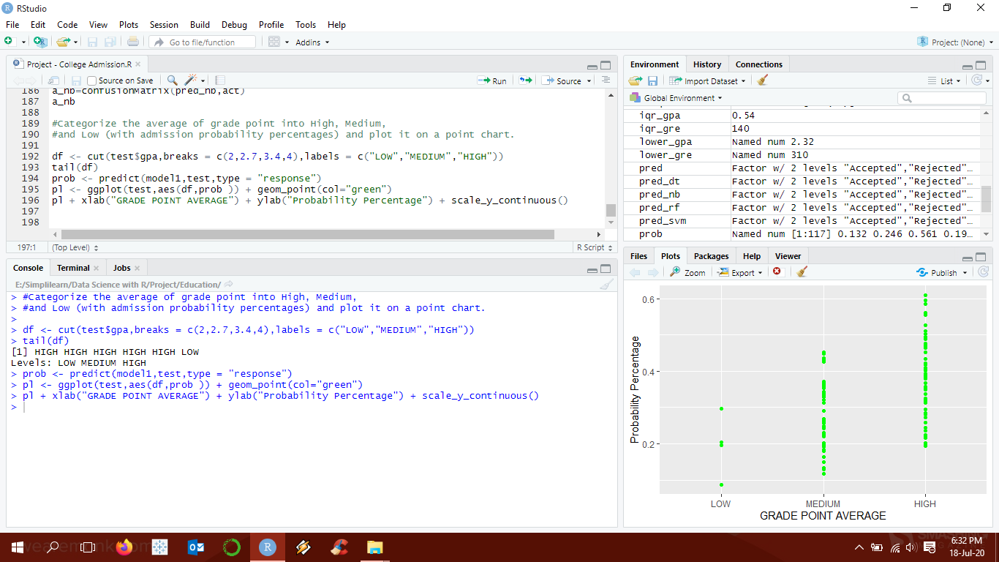

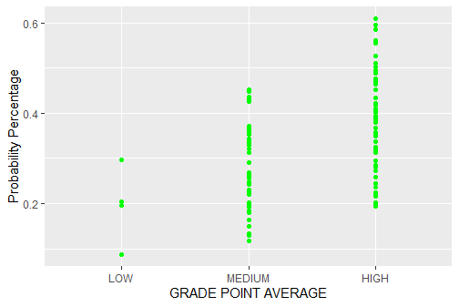

**Programming Codes:**

#Reading Comcast Data and loading libraries

rm(list=ls())

library(dplyr)

library(ggplot2)

library(lubridate)

library(plyr)

library(tidyverse)

library(caret)

library(rattle)

library(party) # For decision tree

library(rpart) # for Rpart

library(rpart.plot) #for Rpart plot

library(lattice) # Used for Data Visualization

library(randomForest)# FOr Random Forest

library(pROC)

library(e1071) # For SVM

library(naivebayes) # For Naive Bayes

setwd("E:\\Simplilearn\\Data Science with R\\Project\\Education")

ca<- read.csv("College_Admission.csv")

head(ca)

# Missing Data

sum(is.na(ca))

anyNA(ca)

#Checking outliers

attach(ca)

par(mfrow=c(1,2))

boxplot(ca$gre, main="Boxplot of GRE")

boxplot(ca$gpa, main="Boxplot of GPA")

#Performing Outlier treatment

#Removing outliers for gre

Q_gre <- quantile(ca$gre, probs = c(0.25, 0.75)) # 25% is 520 and 75% is 660

iqr_gre <- IQR(ca$gre) # Interquantile range is 140

uper_gre <- Q_gre[2]+1.5*iqr_gre # uper limit is 870

lower_gre <- Q_gre[1]-1.5*iqr_gre # lower limit is 310

ca <- subset(ca, ca$gre > lower_gre & ca$gre < uper_gre)

#Removing outliers for gpa on already removed dataset

Q_gpa <- quantile(ca$gpa, probs = c(0.25, 0.75)) # 25% is 3.13 and 75% is 3.67

iqr_gpa <- IQR(ca$gpa) # Interquantile range is 0.54

uper_gpa <- Q_gpa[2]+1.5*iqr_gpa # uper limit is 4.48

lower_gpa <- Q_gpa[1]-1.5*iqr_gpa # lower limit is 2.32

ca <- subset(ca, ca$gpa > lower_gpa & ca$gpa < uper_gpa)

par(mfrow=c(1,2))

boxplot(ca$gre, main="Boxplot of GRE")

boxplot(ca$gpa, main="Boxplot of GPA")

#Factoring the categorical data

str(ca)

ca$admit = factor(ca$admit, levels = c("0","1"), labels = c("Accepted","Rejected"))

ca$ses = factor(ca$ses, levels = c("1","2",'3'), labels = c("Low","Medium",'High'))

ca$Gender_Male = factor(ca$Gender_Male, levels = c("0","1"), labels = c("Female","Male"))

ca$Race = factor(ca$Race, levels = c("1","2",'3'), labels = c("Hispanic","Asian",'African-American'))

ca$rank <- factor(ca$rank, order = TRUE)

#Categorising GRE Marks to Category

ca = mutate(ca,GRE_category = ifelse(gre <= 440,"Low",

ifelse(gre<=580,"Medium","High")))

Freq= table(ca$GRE_category)

Freq

#Checking if normally distributed

summary(ca)

# Density plot

par(mfrow=c(1,2))

d <- density(ca$gpa)

plot(d, main="Kernel Density of GPA")

polygon(d, col="red", border="blue")

d1 <- density(ca$gre)

plot(d1, main="Kernel Density of GRE")

polygon(d1, col="red", border="blue")

hist(ca$gpa, freq = FALSE)

x <- seq(0, 4, length.out=100)

y <- with(ca, dnorm(x, mean(gpa), sd(gpa)))

lines(x, y, col = "red")

hist(ca$gpa, freq = FALSE)

x <- seq(0, 4, length.out=100)

y <- with(ca, dnorm(x, mean(gpa), sd(gpa)))

lines(x, y, col = "red")

#Normalise the data

ca$gpa1 <- scale(ca$gpa)

ca$gre1 <- scale(ca$gre)

hist(ca$gpa1, freq = FALSE)

x <- seq(-3, 3, length.out=100)

y <- with(ca, dnorm(x, mean(gpa1), sd(gpa1)))

lines(x, y, col = "blue")

hist(ca$gre1, freq = FALSE)

x <- seq(-3, 3, length.out=100)

y <- with(ca, dnorm(x, mean(gpa1), sd(gpa1)))

lines(x, y, col = "blue")

#variable reduction techniques to identify significant variables

model <- glm(admit~ ., family = binomial(link = 'logit'), data = ca)

summary(model)

anova(model, test = 'Chisq')

# Logistic regression model with significance independent variable

set.seed(123)

splitIndex <- createDataPartition(ca$admit, p = .70,list = FALSE, times = 1)

train <- ca[ splitIndex,]

test <- ca[-splitIndex,]

model1 <- glm(admit~ gpa1+gre1+rank , data = train,family=binomial(link = "logit"))

summary(model1)

#accuracy of the model and run validation techniques

#Predict on Test through Model

pred = predict(model1,test, type="response")

pred = ifelse(pred>0.5,1,0)

pred = factor(pred, levels = c("0","1"), labels = c("Accepted","Rejected"))

####Validate the model - Confusion Matrix##

act <- test$admit

# Accuracy

table(pred, act)

a=confusionMatrix(pred, act)

a

#Model generation using other ML techniques

#1. Decision tree

model_dt = rpart(admit~ gpa1+gre1+rank, data = train,method = "class",

control = rpart.control(minsplit = 30,cp = 0.01))

par(mfrow=c(1,1))

fancyRpartPlot(model_dt)

pred_dt = predict(model_dt,test, type="class")

table(pred_dt, act)

a_dt=confusionMatrix(pred_dt,act)

a_dt

#2. SVM

svmfit =svm(admit~ gpa1+gre1+rank, data = train, kernel="linear",

scale = T)

pred_svm = predict(svmfit,test, type="response")

table(pred_svm, act)

a_svm=confusionMatrix(pred_svm,act)

a_svm

#3. Random Forest

fit_rf = randomForest(admit~ gpa1+gre1+rank, data = train, do.trace=F)

pred_rf = predict(fit_rf,test)

table(pred_rf, act)

a_rf=confusionMatrix(pred_rf,act)

a_rf

#4. Naive Bayes

fit_nb = naive_bayes(admit~ gpa1+gre1+rank, data = train)

pred_nb = predict(fit_rf,test)

table(pred_nb, act)

a_nb=confusionMatrix(pred_nb,act)

a_nb

#Categorize the average of grade point into High, Medium,

#and Low (with admission probability percentages) and plot it on a point chart.

df <- cut(test$gpa,breaks = c(2,2.7,3.4,4),labels = c("LOW","MEDIUM","HIGH"))

tail(df)

prob <- predict(model1,test,type = "response")

pl <- ggplot(test,aes(df,prob )) + geom_point(col="green")

pl + xlab("GRADE POINT AVERAGE") + ylab("Probability Percentage") + scale_y_continuous()

-------------------------------------------------------------------The End-------------------------------------------------------------------